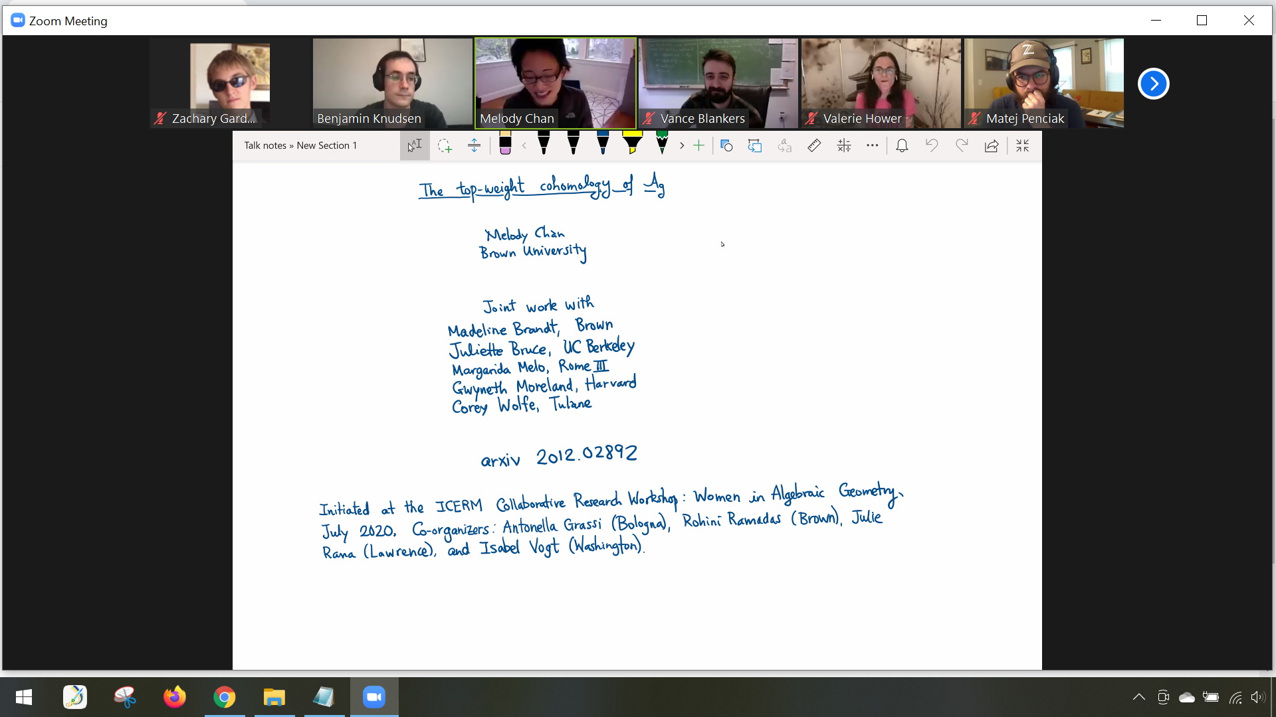

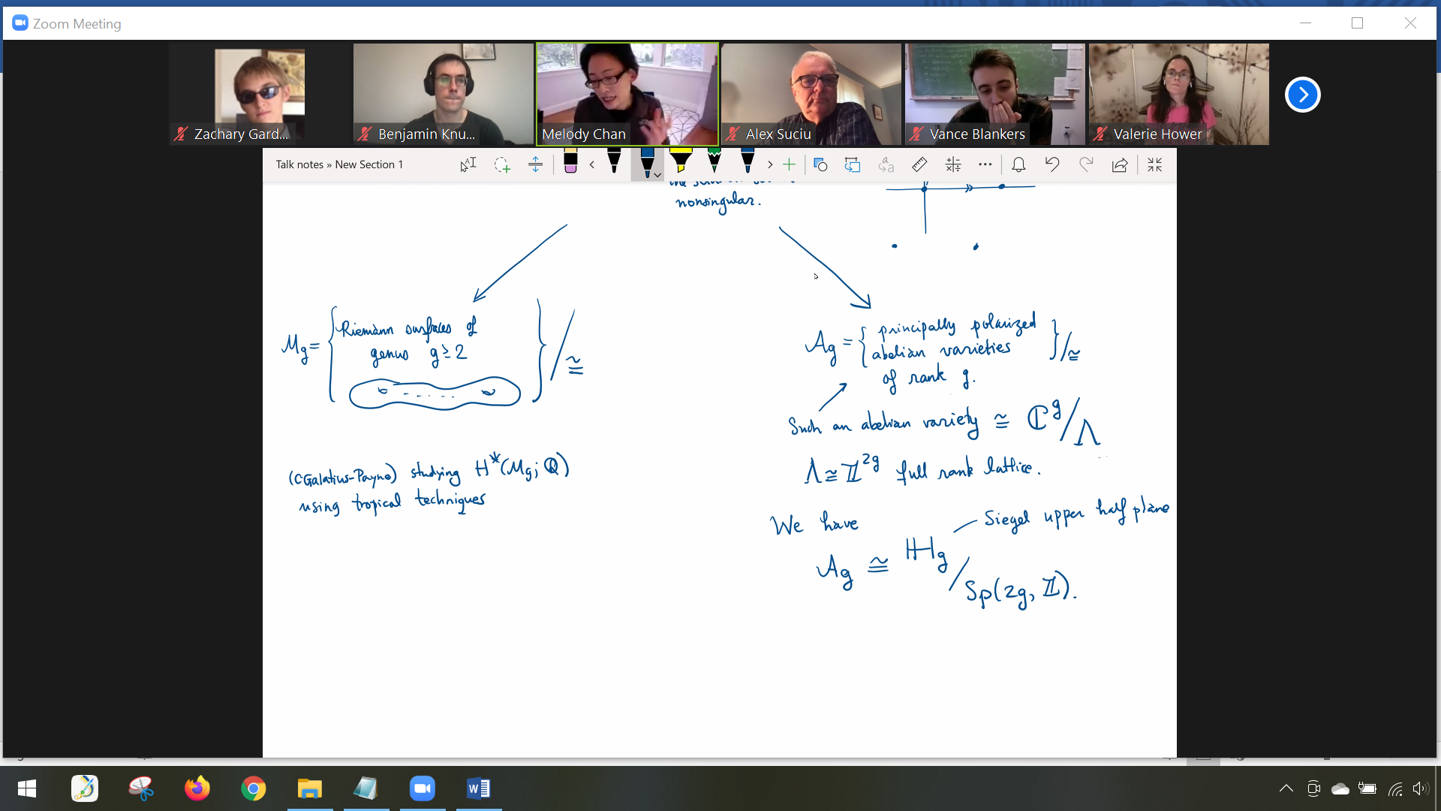

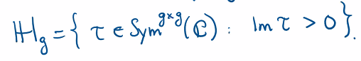

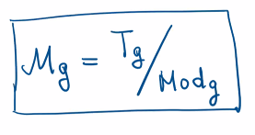

Teichmuller space mod mapping class group (T_g is a contractible space)



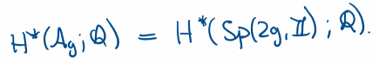

Very important that the things on the right have structure of algebraic varieties. This is a bit sloppy – more precisely they are Deligne-Mumford stacks.

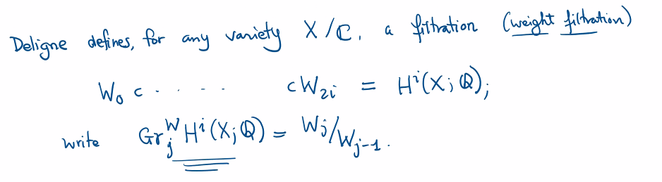

Such things naturally inherit (pure) Hodge structures.

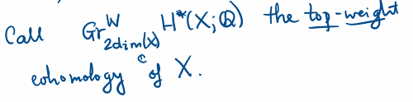

Here we are implicitly asserting that cohomology is supported in these degrees. This is not hard to see if you believe in the functoriality of these constructions (and compatibility with some form of Poincare duality).

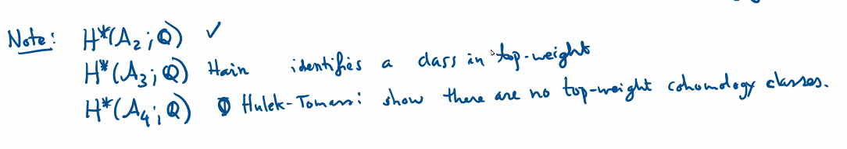

Remark: Hain’s results show there is one top weight cohomology class.

The methods of our project can be used to re-derive these results, as well as some new results.

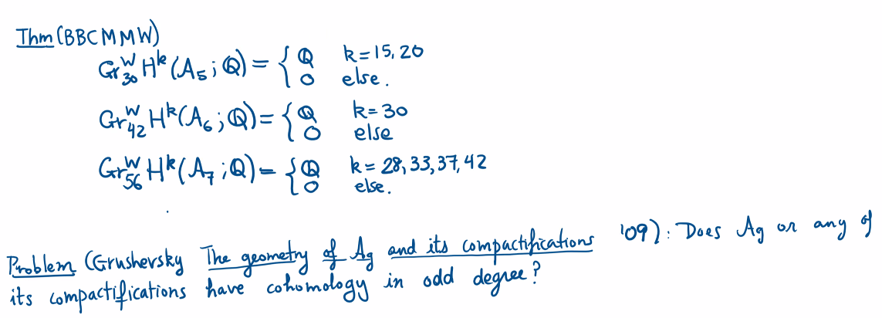

Remark: For M_g, we know there must be “a lot” of odd degree classes because of counting arguments due to Harer-Zagier using Euler characteristic. Actually getting our hands on these classes is difficult, however.

Remark: Things naturally coming from C live in even degrees.

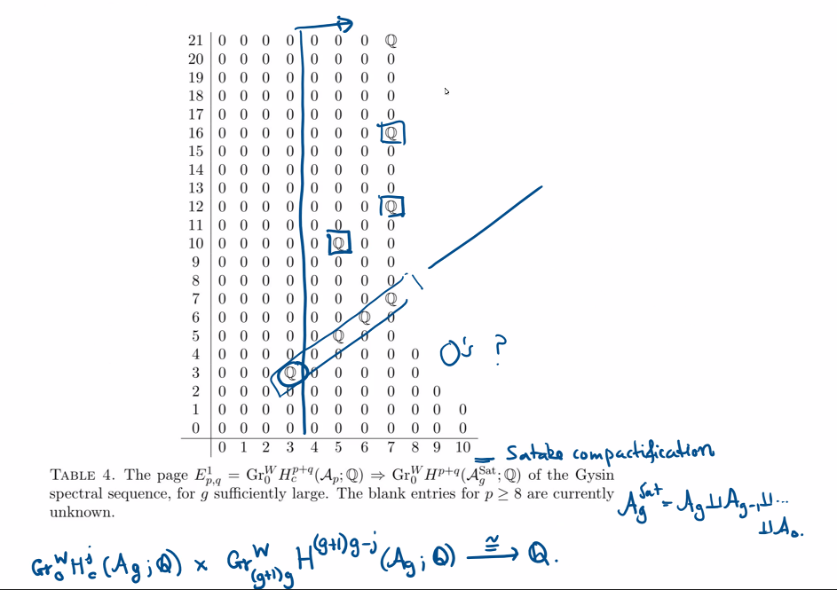

There are lots of things we don’t know here.

* What happens on the E^2 page? (Apparently this has something to do with normal data and Euler classes…)
* Does everything vanish below the diagonal?
* Is there any meaning to the “gaps” on the diagonal? Are there gaps infinitely far out or do they stop at some (potentially large) finite point?
* What’s going on with the mysterious nonzero classes above the diagonal? We know they have to vanish by the E^{\infty} page for reasons… (which I don’t understand). So, something has to kill them along the way… (something something differentials).